Generation of Atypical Chemokine Receptor 3 (ackr3a) overexpressing Danio rerio using Gateway Cloning

By: Xidi Feng, Claudia Chiu, and Dr. Ching-Ling Lien
Abstract:
Previous studies from the Lien lab have shown increased lymphangiogenesis in decoy receptor atypical chemokine receptor 3 (ackr3a) D. rerio (also known as zebrafish) mutants correlating with normal health, measured in lifespan, activity, appearance, and appetite. With this in consideration, this study aims to generate zebrafish with overexpression of ackr3a, to further clarify the role of ackr3a in lymphangiogenesis and clearance of scar tissue after injury. To do so, it is necessary to generate a line of ackr3a overexpressed fish using methods of gateway cloning to generate pA2-ubb-loxp-H2B-cerulean-stop-loxp-ackr3a vectors for microinjection into WT zebrafish eggs. A 50ng/ul concentration of tol2 transposase mRNA and plasmid was inserted into eggs at the one cell stage but not into the yolk. When incubated at 37 C, only one fish with faint markings for the positive genotype persisted. Other fish with stronger cerulean markings had abnormal phenotypes and would not survive until adulthood. This suggests that the vector inserted influences the physiological development of the fish at higher concentrations. AS such, follow-up experiments should take into account the concentration of the injection material; perhaps a lower concentration such as 25 ng/ul would yield greater numbers successful transgenic fish.

Introduction:
With myocardial infarctions being one of the leading causes of deaths, treatment of this irreversible disease has become a public health concern. In mammals, cardiomyocyte renewal is limited--upon injury, they die and form permanent scar tissue, reducing the ability of the heart to pump blood to the rest of the body. Unlike mammals, zebrafish have the ability to regenerate cardiac muscle and decrease scar formation. As such, zebrafish have become of interest to study--greater insight into how its genetic makeup can stimulate cardiomyocyte proliferation and removal of scar tissue will allow for consideration of the treatment of myocardial infarctions from another perspective.
Due to the immune clearance properties of the lymphatic system, it can be hypothesized that the lymphatic system may have a positive role in the fish’s ability to decrease scar tissue. As such, the cxcr7 gene family, which the lack of has been shown to stimulate proliferation of lymphatic endothelial cells in mice, has become a target for investigation. (Klein et al., 2014). In zebrafish, there exists both the ackr3a and ackr3b genes which belong to the cxcr7 family. Preliminary studies from the Lien lab show that ackr3a mutants have increased lymphangiogenesis while ackr3b mutants have normal levels of lymphangiogenesis in the heart in comparison to wild-type fish. In addition to a more pronounced lymphatic system, ackr3a mutants appear to be healthy fish, having normal lifespans, activity, appearance and appetite.
The purpose of this study is to generate zebrafish with overexpression of ackr3a, in order to further examine how the genotype affects the health of zebrafish and the development of its lymphatic system in the heart in future studies. To do so, the gateway cloning technique was used to insert entry clones into a destination vector to create the desired pA2-ubb-loxp-H2B-cerulean-stop-loxp-ackr3a plasmid. This plasmid was then inserted into WT zebrafish embryos at the one-cell stage using techniques of microinjection. The transgenic embryos were then incubated at 37 $℃$ for four days until they hatched and screened for successful transformation. As marked by the cerulean marker, successful transgenic fish will have a normal phenotype (no abnormal growths) and bright spots on its underside when viewed under the blue fluorescent protein filter under the microscope.
Methods:
The Gateway Cloning Technique was used to design the plasmid for insertion into zebrafish. It allows for more efficient replication of genetic vectors using the transformative properties of bacteria rather than lengthy PCR processes. This technique is composed of BP and LR reactions which will be described in detail below.
BP reaction
BP reactions purport to synthesize entry clones for insertion into a destination vector, and pertaining to this experiment, are harnessed to generate the p3E-ackr3a entry clone. The main components of this process include amplification of genetic material, purification, recombination and transformation.
PCR Amplification of DNA
Total RNA was extracted from 10 WT zebrafish hearts. mRNA was reverse transcribed to cDNA by oligo dT primer. Running PCR with aattB3-ackr3a-R and attB2-ackr3a 2F primers allowed for amplification of the ackr3a target sequence.
Purification of PCR Products
PCR products were run in gel and the appropriate band was excised. The DNA was then purified using Invitrogen’s QIAquick PCR purification kit.
BP Recombination Reaction of the donor vector and purified PCR product to create p3E-ackr3a entry clone vector
Gateway BP clonase enzyme mix was used to recombine attb2-attb3 flanked ackr3a PCR product into pDONRp2r-p3 vector
Transformation and Diagnostic tests
p3E-ackr3a entry clone vector was added to oneshot top-10 cells for transformation and cultivated on vancomycin positive agar. Colonies that result were then picked for plasmid extraction using Invitrogen’s QIAprep spin miniprep kit. The plasmids were then digested using M13 primers, which yields bands around 1500 bp if transformation is successful. Invitrogen’s hyperladder 100bp, which accommodates bands of size 100 to 2000 bp, was used to evaluate the fragments using gel electrophoresis. The colonies of the most prominent and accurate bands were sent for sequencing to ensure the correct sequence of the clone.

LR reaction
LR reactions were harnessed to to synthesize pA2-ubb-loxp-H2B-cerulean-stop-loxp-ackr3a vector. Using Invitrogen Gateway LR Clonase II plus, existing entry clones p5E-ubb promoter and pME-loxp-H2B-cerulean-stop-loxp were recombined with p3E-ackr3a entry clone into destination vector pDEST-Tol2pA2.
Transformation, Plasmid Prep, and Diagnostic Tests
Again, the vector was added to transform oneshot top-10 cells. These cells were then cultivated on LB/amp plate. As the destination vector is ampicillin resistant, survival of colonies may indicate successful transformation. Additionally, clear colonies were also selected for miniprep and testing via restriction as clear colonies usually indicate the correct clone. Plasmid was then extracted from these clear colonies using Invitrogen’s QIAprep spin miniprep kit. The plasmids were then digested using Age1 and Sp1 primers, which yields three bands around 5477, 3554, and 1769 bp if transformation is successful. Invitrogen’s Kb Plus DNA ladder, which accommodates bands ranging from 100bp to 1500 bp, was used to evaluate the fragments using gel electrophoresis. The plasmid of the two most prominent bands were sent to be sequenced in order to verify the correct placement of the insertions.
Microinjection of vector into WT zebrafish embryo
The injection material was prepared with a 50ng/ul concentration for both tol2 transposase mRNA and plasmid in water. After preparation of the injection material, eggs were collected in the morning from WT zebrafish. Following standard microinjection protocol, the microloader pipette was loaded with 0.015nl of injection material and inserted into the egg at the one cell stage.
Screening of embryos
After the majority of the remaining zebrafish embryos have hatched, they were screened through a blue fluorescent protein filter under the microscope for the cerulean marker which would indicate successful recombination of the pA2-ubb-loxp-H2B-cerulean-stop-loxp-ackr3a vector into the WT zebrafish genome. Embryos positive for ackr3a overexpression were allowed to mature into adult fish for further study.

Results and Discussion:
Extraction of the p3E-ackr3a entry clone from transformed oneshot top-10 cells yielded mostly bands of around 1500 bp, except for the first colony which was slightly under 1000 bp. (figure 1).
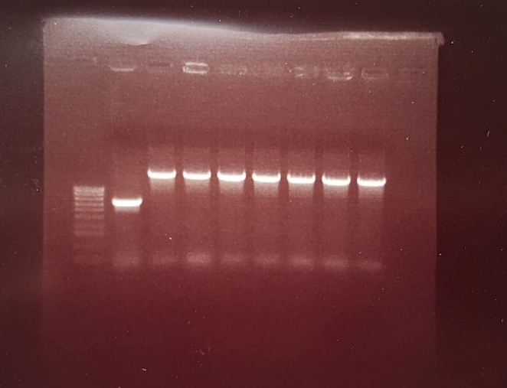
Figure 1: Gel analysis of fragments after digestion of the p3E-ackr3a entry plasmid with M13 primer. With the exception of colony 1 (from left to right), colonies 2-8 yielded bands of fragments around 1500 bp, the target size of the fragments after digestion. A few of these colonies were sent in for sequencing, which further confirmed the correct sequence.

The successful p3E-ackr3a entry clone was then recombined with entry clones p5E-ubb promoter and pME-loxp-H2B-cerulean-stop-loxp into destination vector pDEST-Tol2pA2 to generate the resulting pA2-ubb-loxp-H2B-cerulean-stop-loxp-ackr3a vector. Extraction of the pA2-ubb-loxp-H2B-cerulean-stop-loxp-ackr3a plasmid from transformed oneshot top-10 cells produced a few colonies which yielded fragments of size 5477, 3554, and 1769 bp, with colonies 4 and 5 having the most prominent bands. (figure 2). The plasmids from these colonies were sent in for sequencing.
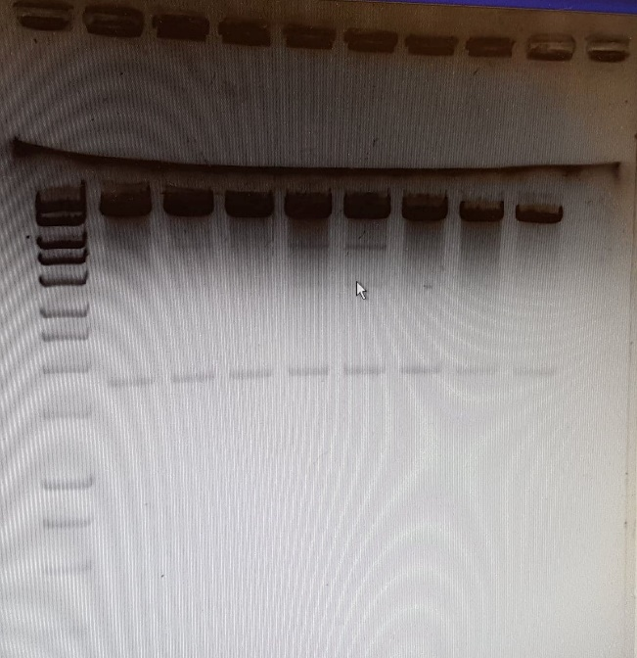
Figure 2: Gel analysis of fragments after digestion of the pA2-ubb-loxp-H2B-cerulean-stop-loxp-ackr3a plasmid with Age1 and Sp1 primer. Many of these colonies yielded bands of fragments around 5477, 3554, and 1769 bp, the target size of the fragments after digestion, but colonies 4 and 5 had the most prominent bands. They were sent in for sequencing.

After injection of 100 embryos with 50 nl/ul diluted tol2 transposase mRNA and plasmid injection material, only one fish positive for ackr3a overexpression survived the injection. In comparing the images taken between wild type and ackr3a overexpressed fish which have normal physiological development, the latter possesses small markings of the cerulean marker along its underside while the WT fish completely does not.
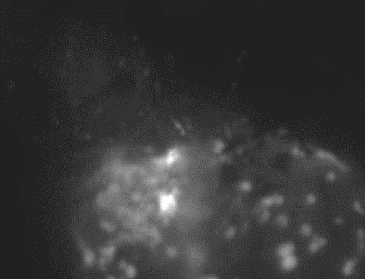
Figure 3: From left to right: a WT fish, a pA2-ubb-loxp-H2B-cerulean-stop-loxp-ackr3a positive fish, and a pA2-ubb-loxp-H2B-cerulean-stop-loxp-ackr3a positive fish with abnormal physiological development when viewed through the BFP filter under the microscope.

However, it is seen in figure 3 that the cerulean marker which marks ackr3a overexpression is much more prominent on the fish which don’t have normal physiological development. The fish with abnormal physiological development remained in the more spherical structure of the embryo instead of the normal larvae structure, as shown below for comparison.
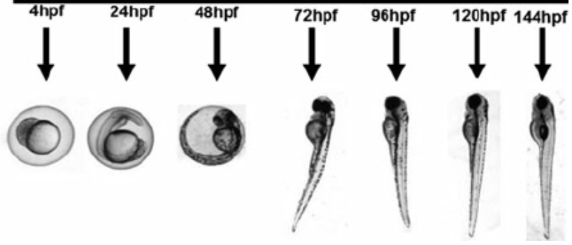
Figure 4: Developmental stages of zebrafish in hours post fertilization. After the zebrafish hatches from its embryo, it begins to gain a more fish-like structure, moving from the mass-like structure it was previously. (Oyarbide, 2012).

This suggests that too high a concentration of the pA2-ubb-loxp-H2B-cerulean-stop-loxp-ackr3a injection material influences the physiological development and consequently, the health of the fish, leading to death and abnormal phenotypes. To improve upon the number of surviving transgenic fish, the injection concentration can be lowered to 25ng/ul on the next set of injections, which had been more successful in previous experiments conducted by the lab to generate transgenic fish using gateway cloning.
After the transgenic fish have been successfully generated, the role of lymphangiogenesis in scar recovery can further be clarified. To do so, cryoinjuries will be placed on the hearts of ackr3a overexpressed and WT fish and the healing process monitored. As AFOG staining marks presence of fibrin and collagen, the major components of scar tissue, staining heart samples using this dye will allow for observation of changes to the size of the scar tissue caused by the cryoinjury indicative of each fish’s ability to recover from cardiac tissue death.

Works Cited:
Klein, K. R., Karpinich, N. O., Espenschied, S. T., Willcockson, H. H., Dunworth, W. P., Hoopes, S. L., … Caron, K. M. (2014). Decoy receptor CXCR7 modulates adrenomedullin-mediated cardiac and lymphatic vascular development. Developmental cell, 30(5), 528–540. doi:10.1016/j.devcel.2014.07.012

Oyarbide, Usua & Rainieri, Sandra & Pardo, Miguel. (2012). Zebrafish (Danio rerio) Larvae as a System to Test the Efficacy of Polysaccharides as Immunostimulants. Zebrafish. 9. 74-84. 10.1089/zeb.2011.0724.

